Ant Esports Dynamic GT Mid Tower ARGB Gaming Cabinet

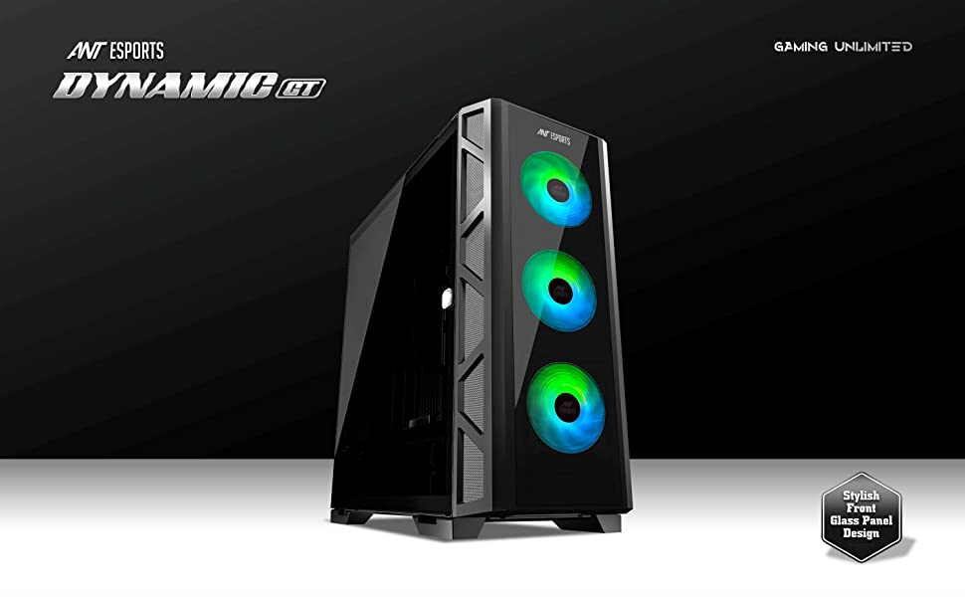Take your gaming PC to the next level with the Ant Esports Dynamic GT, a case designed as per current gaming trends as well as the need for modern-day hardware. The case offers high accommodation capacity, impressive cooling, and the right balance of RGB to create the perfect build that not only looks great but even runs cool.A black computer tower with green lights
The Dynamic GT can house up to twelve 120mm fans out of which four ARGB 120mm come pre-installed out of the box ensuring a direct air flow to keep your high TDP components cool even under full load. In terms of liquid cooling support, the case can not only house upto a 360m radiator on top but also house a 240mm radiator on the side for that unique look that not only sets your build apart but also provides better airflow making it suitable for high-end gaming PCs and builds.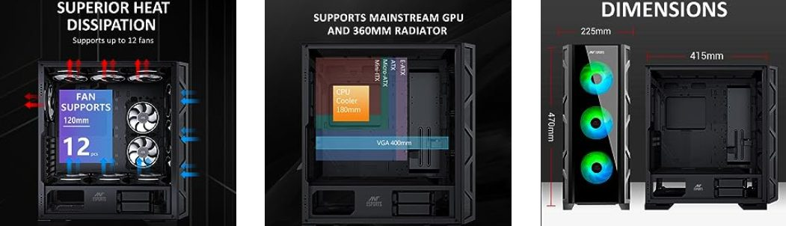For the air cooler, the case offers a massive 175mm clearance making it compatible with every beefy air cooler out in the market so you can create your favorite air-cooled build. Two 3.5” HDD and four 2.5” SSD can be installed simultaneously while the dedicated wire management doors impart a cleaners look and hassle-free building process even for complicated builds.A rich IO panel with two USB 2.0 ports and one USB 3.0 port along with magnetic side panels that are equipped with handles makes the Dynamic GT an elegant and convenient case to build in for experienced and new system builders alike.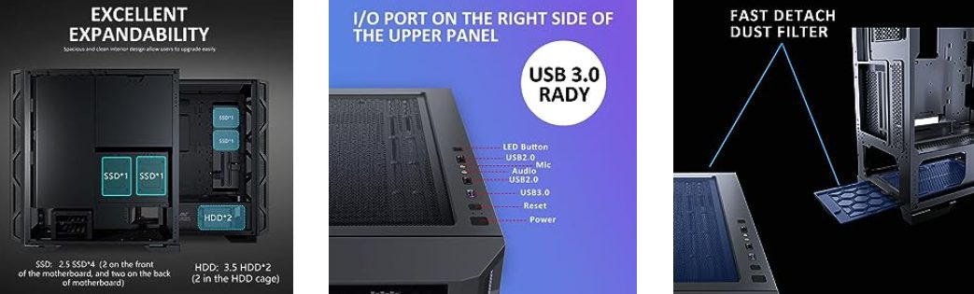

* **Multiple Radiator Mounts –** For enthusiast-grade cooling dual 360-millimeter radiators are supported on the top and front panel while a single 240mm is supported on the side to keep the most extreme systems cool.
* **Large Storage Options –** With four 2.5” SSD mounts and dual 3.5” HDD mounts the Ant Esports Dynamic GT is ideal to build any gaming or production system.
* **Hassle-Free Building Experience –** The case offers dedicated cable covers at the back for swift wire management and a hinged magnetic side panel with a handle to ensure a hassle-free and convenient system-building experience.
* **Spacious Interiors –** The spacious interior fits up to an E-ATX motherboard configuration. Support for up to a 400mm graphics card, twelve 120mm fans, and a 175mm CPU cooler provide room for optimum cooling along with future upgrades.
* **Rich IO Panel –** The case comes with two USB 2.0 ports, one USB 3.0, and one LED button along with power and audio ports.

|  |  |  |
| --- | --- | --- |
| Dimensions ( L x W x H ) | Chassis Size | 415 x 225 x 470 mm |
| Packing Size | 532 x 283 x 542 mm |
| Motherboard Type | | E-ATX, ATX, Micro-ATX, Mini-ITX |
| Drive Bays | 3.5 Inch | 2 HDD + 2 SSD or 4 SSD |
| 2.5 Inch |
| 5.25 Inch | None |
| Fan Support | Front | 120 mm x 3 / 140 mm x 3 |
| Top | 120 mm x 3 / 140 mm x 3 |
| Bottom | 120 mm x 3 |
| Rear | 120 mm x 1 |
| Side | 120 mm x 2 |
| Liquid Cooling Support       (Maximum) | Front | 120 / 240 / 280 / 360 mm |
| Rear | 120 mm |
| Top | 120 / 240 / 280 / 360 mm |
| Pre-Installed Fans | x 3 Front Fans, x 1 Rear Fan | |
| Compatibility                     ( Maximum ) | VGA Card Length | 400 mm |
| CPU Cooler Height | 175 mm |
| I/O Panel | 2 x USB 2.0, 1 x USB 3.0, 1 x Audio In, 1 x Mic | |
| Expansion Slots | | 7 |